Heinrich Hertz Technical Paper 2020

By James Duffy (17206286) and Eoin Flynn (15179818)

University of Limerick
E-mail: James Duffy 17206286@studentmail.ul.ie
Eoin Flynn 15179818@studentmail.ul.ie

ABSTRACT

Our modern world stands on the shoulders of our ancestors. Their findings form the foundations that inspire our today. Herinrich Hertz is one such historical person. He was the first person to conclusively prove the existence of electromagnetic waves via precise experimentation procedures. He also created scientific instruments to generate and detect these waves across space.

This paper provides insight into Hertz, the man who truly changed the world with his findings. Specifically, it focuses on his technological achievements along with their impact and applications.

- Introduction

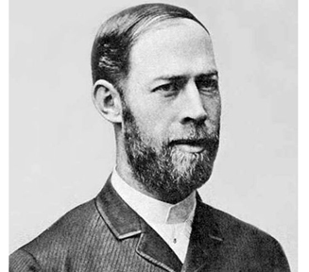
Figure 1.1 – Heinrich Hertz Source-Nationalmaglab.org

Heinrich Rudolf Hertz was born on February 22nd, 1857, in Hamburg and died January 1st, 1894. He showed that the Scottish physicist James Clerk Maxwell’s studies and theory on electromagnetism was indeed correct, proving that light and heat are forms of electromagnetic radiation.
The unit of frequency, cycles per second, was named after him. [1]
In this paper, we will discuss Hertz’s background, his influences, his technological advancements, the impact of these advancements and how they are applied to have changed the world.
II. Background

A. Early Life

Heinrich Hertz was the eldest born of five children in Hamburg. As a child he showed an interest in creating scientific tools, promptly building a spectroscope and a galvanometer when he became a teenager. The quality and design of which were so great he used them throughout his college years. Initially, Hertz planned to pursue a career in engineering, but after experiencing what his life would be like after enrolling in Polytechnic for a Summer, he finally decided to pursue what more deeply interested him: science.

B. Introduction to Science

Hertz was introduced to science from a very young age, reading science works and carrying out experiments as a hobby. In 1877 Hertz gained laboratory experience under Gustav von Jolly, a mathematician and physicist. Soon after, he was privileged to study under the great Hermann von Helmhotlz, who proved to be a massive influence for Hertz. He found learning through this method of experimentation very impactful, and sent a letter to his family stating: "I cannot tell you how much more satisfaction it gives me to gain knowledge for myself and for others directly from nature, rather than merely learning from others and for myself alone." [2]

III. Influences

- Hermann Von Helmhotlz
As previously mentioned, Hermann Von Helmhotlz was a huge influence on Hertz. With Helmhotz’s encouragement, Hertz decided to compete for a research prize to be awarded to the student able to determine if electricity moved with inertia. Two years later, he succeeded and won the prize. Interestingly Helmhotz proposed another prize to prove electromagnetic circulating which Hertz did not immediately undertake, but years later would be the first person to provide definitive evidence that was sought. This combination of work lead to Hertz receiving his doctorate in 1880, magna cum lade. This might not have occurred if not for Helmhotz’s influence.

IV. Technological Achievements

- Electromagnetic waves
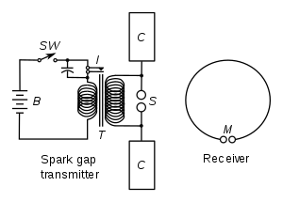
Figure 4.1 – Diagram illustrating apparatus for generating and detecting radio waves. A spark transmitter with a spark gap is powered by high voltage pulses from a Ruhmkorff coil (denoted as T in the diagram). The receiver consists of a spark gap and a loop antenna.

In autumn of 1886, Hertz noticed that discharging a Leyden jar (an early day capacitor). He used a Ruhmkorff coil (a type of transformer used to produce high voltage pulses from low DC supplies) driven spark gap (radio transmitter that produces radio waves by means of a spark) as a radiator. His receiver consisted of a loop antenna and a micrometer spark gap (a device used to measure potential in an electrical circuit [3]

- Dipole Antenna
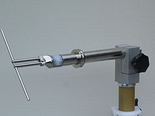
Figure 4.2 – UHF half-wave dipole.
The dipole is the simplest type of antenna, invented by Hertz. It simply consists of two conductors of equal length in the end-to-end orientation with feedlines connecting the two. [4]

- Radio Transmitter
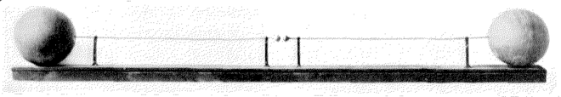
Figure 4.3 – Hertz’ first radio transmitter
Created only by one-meter copper wires with a 7.5mm spark gap between them and a pair of 30cm zinc spheres at the end.
When Hertz powered this transmitter (with an induction coil) it produced waves at a frequency of around 50MHz, proving Maxwell’s theory that electric and magnetic fields could travel through space (electromagnetic waves).

- Radar
While gathering data to show the existence of electromagnetic waves, Hertz discovered that radio waves are reflected by metallic objects. This was the foundation for the technician Christian Hulsmeyer to carry out the first detection experiment using radar waves in 1904.

- Photoelectric Effect
In 1887, Heinrich Hertz discovered the photoelectric effect. In connection to Hertz’ work on radio waves he observed and reported on the production and reception of electromagnetic waves caused by the photoelectric effect. [5]

The observation Hertz made was that when ultraviolet light shines on two metal electrodes with a voltage applied across them, a spark occurs between the two electrodes as the light alters the voltage. Hertz made two observations from this, the photoelectric effect and the production and reception of electromagnetic waves, these observations were published in the journal Annalen der Physik.
Another German physicist named Philipp Lenard added further clarification to this. Philipp demonstrated the liberation of electrically charged particles from the surface of a metal when it is illuminated. These liberated were found to be identical to electrons which had been discovered by the British physicist Joseph John Thomson in 1887.
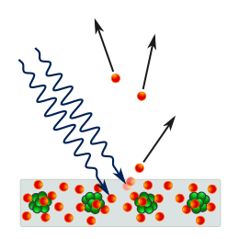
Figure 4.4 - A metal place hit by light quanta/ photons emitting electrons.

The photoelectric effect was found to represent an interaction between light and matter that at the time could not be explained by classical physics, in which light is described as an electromagnetic wave. According to wave theory the maximum kinetic energy of the electrons released due to the photoelectric effect should have been proportional to the intensity of the light, but rather it was varying in proportion to the light’s frequency instead. The lights intensity instead determined the number of electrons released from the metal, which was measured as an electrical current. A second puzzling observation was that the time between the arrival of radiation and the emission of electrons had virtually no lag between them.

Hertz had a receiver made up of a coil with a spark gap. Upon detecting electromagnetic waves (EM) a spark would be seen. In order to see the spark more easily the apparatus was placed inside of a dark box. But Hertz then observed that the maximum spark length was shorter when inside the box. The glass panel placed between the source of electromagnetic waves and the receiver was absorbing the ultraviolet that would otherwise assist the electrons in jumping across the gap. The glass was swapped out for quartz and there was no longer a decrease in spark game distance. Quartz does not absorb ultraviolet radiation.
This went on to be dubbed the Hertz effect and was further investigated by Hallwachs, Hoor, Righi and Stoletov on the effect of light.
After months of work Hertz concluded his investigation and reported the results he obtained. Hertz himself did not make any attempt to pursue this effect, just doing the experiment, recording the results, and not explaining how the phenomenon comes about but just highlighting it exists. This laid the foundation for the photoelectric effect to be studied by many other bright minds, bringing us many varying benefits today.

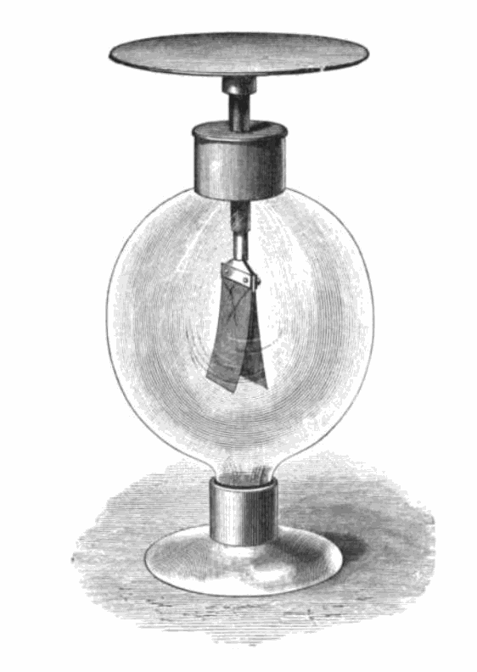
Figure 4.5 - Gold leaf electroscope used to demonstrate the photoelectric effect. [987]
- Parabolic Antenna

In 1888 Heinrich Hertz developed the first parabolic reflector antenna. The idea for using parabolic reflectors for radio antennas came from optics. In optics it can easily be shown how a parabolic mirror can focus light into a beam, concentrating the light together. This same theory can be applied to radio waves, in that the scattered waved can be made more substantial using the parabolic reflector antenna.

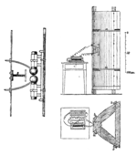
Figure 4.6 - The first parabolic antenna, which Hertz developed in 1888. [14]

However, it was not until World War II which began in 1939 that parabolic antenna found itself widely used. This was due to radio still only using lower frequencies prior to this as radio was only in early development. At this point electromagnetic frequencies could be exploited, and the work Hertz did to develop the parabolic reflector antenna bore fruit. Now parabolic antennae are used as high-gain antennas for point-to-point communications.

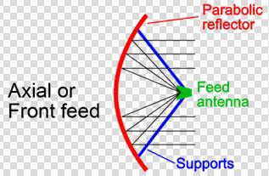
Figure 4.7 - Diagram of a front feed parabolic reflector antenna.[15]

In figure 4.7 it can be seen that the dish on the left (coloured in red) is hit by and reflects the radio waves towards a focal point. At the focal point a feed antenna (coloured in green) is located to take in the radio waves reflected towards it. The supports for the feed antenna (coloured in blue) are obstructive to incoming radio waves and drop the aperture efficiency to 55-60% [6]

V. Impact and Applications

Hertz, despite proving Maxwell’s theory felt like this was in no way significant. He has stated: “I do not think that the radio waves I have discovered will have any practical application”. When asked about the applications of his discoveries, he replied “Nothing, I guess”. This could not be further from the truth as many of his inventions have changed the world.
Hertz’s proof of electromagnetic waves led to a giant amount of experimentation with this newfound form of electromagnetic radiation. Within ten years of his discovery, other researchers employed these radio waves into the first wireless telegraphy radio communication systems. Hertz’s findings are the reason we have radio broadcasting and television.

- Rabbit Ears
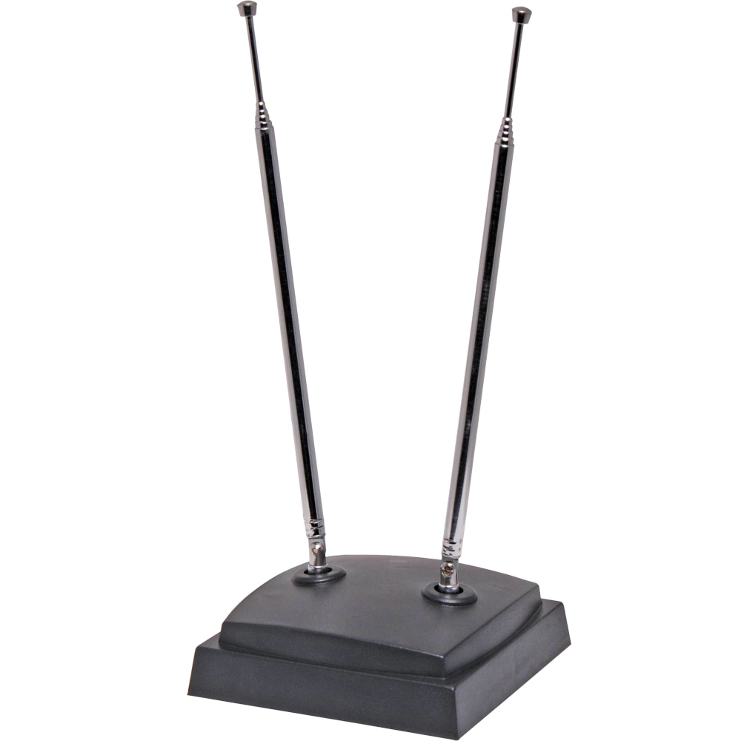
Figure 5.1 – Rabbit ears.

One of the most common applications of the dipole antenna (Figure 4.2) is the rabbit ears. It is constructed of two telescoping rods that can be extended out to 1m length, used to receive the VHF terrestrial television bands.

- Radar
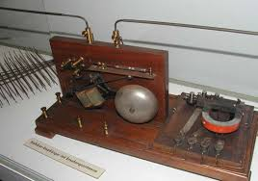
Figure 5.2 – Telemobiloscope
Christian Mulsmeyer created a device called the telemobiloscope. This is a device used to measure the transit time of reflected waves and was the first practical “radar” machine. The most common uses of radar today are navigation and monitoring sea vessels or air traffic. Further scientific applications include the measurement of near-Earth orbit to gain insight into space travel, meteorology (weather radar) and even detection of potentially unstable structure after a landslide.

- Photoelectric Effect
The impacts of Hertz’ discovery of the photoelectric effect is significant and broad, especially when looking at how it laid the foundations for many modern technological achievements.

Hertz’ work became the foundation for many scientists to investigate the photoelectric effect. Hertz lead other scientists to discover many important concepts and qualities of light, some of which include:
- Under certain circumstances light can ionize gases – Philipp Lenard in 1900 [7]
- The concept of photoelectric emission – Philipp Lenard and Wilhelm Hallwachs 1886-1902 [8]
- Light energy is carried in discrete quantized packets, the energy in each packet is equal to the frequency of light multiplied by a constant, called Planks constant, key in developing quantum mechanics – Max Plank in 1900 [9], Albert Einstein in 1905 [02] proven by Robert Millikan in 1914 [10]
- The photoelectric effect propelled the emerging concept of wave-particle duality in the nature of light. This concept in essence means that light possesses the characteristics of both waves and particles. The effect was impossible to understand with the widely accepted wave description of light at the time. [11][12][13]

The uses and effects of the photoelectric effect are seen in the following:
Photomultipliers, image sensors, photoelectron spectroscopy, night vision devices, spacecraft, moon dust.

A photoelectric cell, otherwise known as photodiode. This was originally a cathode made with a small work function so that electrons would easily be emitted placed inside a vacuum tube. The released electrons are gathered by an anode which is held at a large positive voltage in relation to the cathode. This device has since been replaced by semiconductor-based photodiodes that can detect light, measure light intensity, control other devices as a function of illumination, and turn lights energy into electrical energy. These devices are used in industrial process control, pollution monitoring, light detection withing fiber optics of telecommunications networks, solar cells, imaging and a broad range of other applications.

A photoconductive cell is made of semiconductors with bandgaps that corresponding to the sensed photon energies. Two examples of this are cadmium sulfide, and lead sulfide or mercury cadmium telluride.
Cadmium sulfide has use in automatic switches within streetlights, and photographic exposure meters which operate in the visible spectrum.
Mercury cadmium telluride has use in infrared detectors, which operate as sensors for night vision applications and operate outside of the visible spectrum.

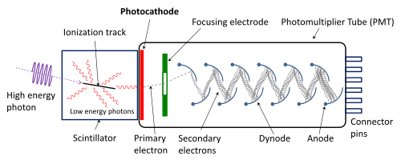
Figure 5.3 – A photomultiplier [16]

A photomultiplier is a device that allows for the conversion of incident photons into an electric signal. A photomultiplier is made inserting a coated photocathode with very low work function inside of a vacuum tube that is extremely light sensitive. When the photocathode is illuminated by very low-level light it readily releases electrons. The photomultiplier contains a series of metal plated dubbed dynodes. The first dynode attracts the electrons released by the cathode, this dynode releases additional electrons that strike the second dynode and so on. The multiplication effect can be observed as the photocurrent is hugely amplified.
The photomultiplier and its solid-state versions with comparable sensitivity are quintessential to spectroscopy research where the measurement of extremely weak light sources is commonplace.
A photomultiplier is paired with scintillation counters which contain a material which produces flashed of light in response to being struck by X-rays or gamma rays, the use of the photomultiplier here is that it can count the flashes and measure their intensity. This seemingly simplistic application has invaluable uses such as identifying isotopes for nuclear tracer analysis and detecting the X-rays used in CAT scans, allowing cross sections of the body to be viewed.

Video camera tubes are a device based on cathode ray tubes that were used as television cameras to capture images. An example of this is the image dissector, which used a screen charged by the photoelectric effect in order to transfer the captured optical image into an electronic signal, which could then be broadcast over electromagnetic waves.

- Parabolic Antenna
Parabolic antenna now finds commonplace use and come in all shapes and sizes. It is through their shape that they are distinguished. The most common of these shapes is the axial, prime focus or front feed.

Parabolic antennae are used as high-gain antennas for point-to-point communications. This use finds applications in our modern-day technology. These antennas are applied as microwave relay links that carry television and telephone signals, wireless WAN/LAN for data transfer, spacecraft and satellite communications, radar, and as radio telescopes.

Due to this widespread use parabolic antennae are widely seen on many modern houses for the homeowners to utilize telephone, internet, television services. Another common sighting of these antenna is on telephone masts that act as the point-to-point network for wide range signal coverage.

X. CONCLUSIONS

It is clear to see that the lives we live would not be the same if not for Heinrich Hertz. Despite this, it is almost comical that Hertz himself thought so little of his discoveries. In just thirty-seven years of life he directly created the first piece of apparatus to view electromagnetic waves, discovered the photoelectric effect, developed the first parabolic antenna, along with notable work in many facets of physics. Hertz paved the way for scientists such as Mulsmever, Lenard, Stoletov, and many more to prosper using his experimental findings.
It was Hertz’ love of experimentation combined with sharing this to the world that led Hertz himself and many others to a broad and deep range of discoveries in physics.

REFERENCES

[1] IEC History. Iec.ch.
[2] (Nationalmaglab.org. 2020. Heinrich Hertz - Maglab. Available at: <https://nationalmaglab.org/education/magnet-academy/history-of-electricity-magnetism/pioneers/heinrich-hertz> [Accessed 15 October 2020].
[3] The creation of scientific effects : Heinrich Hertz and electric waves. Chicago: University of Chicago Press. 1994. ISBN 9780226078915. OCLC 704274080. Retrieved September 25, 2015.
[4] Stutzman, Warren; Thiele, Gary (1981). Antenna Theory and Design. John Wiley & Sons, Inc. pp. 212–220. ISBN 0-471-04458-X.
[5] Hertz, Heinrich (1887). "Ueber einen Einfluss des ultravioletten Lichtes auf die electrische Entladung". Annalen der Physik. 267 (8): 983–1000.
[6] ref- Lehpamer, Harvey (2010). Microwave transmission networks: Planning, Design, and Deployment. US: McGraw Hill Professional. pp. 268–272. ISBN 978-0-07-170122-8.
Bibcode:1887AnP...267.983H. doi:10.1002/andp.18872670827.
[7] Bloch, Eugene (1914). "Recent developments in electromagnetism". Annual Report Of The Board Of Regents Of The Smithsonian Institution 1913. Washington, DC: Smithsonian Institution. p. 239. Retrieved 2 May 2020.
[8] Planck, Max (1901). "Ueber das Gesetz der Energieverteilung im Normalspectrum (On the Law of Distribution of Energy in the Normal Spectrum)". Annalen der Physik. 4 (3): 553. Bibcode:1901AnP...309.553P. doi:10.1002/andp.19013090310.
[9] "The Nobel Prize in Physics 1921". Nobel Foundation. Retrieved 2008-10-09.
[10] Lamb, Jr., Willis E.; Scully, Marlan O. (1968). "The photoelectric effect without photons" (PDF). Coral Gables, FL: Center for Theoretical Physics, University of Miami. we understand the photoeffect as being the result of a classical field falling on a quantized atomic electron
[11] Resnick, Robert (1972) Basic Concepts in Relativity and Early Quantum Theory, Wiley, p. 137, ISBN 0-471-71702-9.
[12] Knight, Randall D. (2004) Physics for Scientists and Engineers with Modern Physics: A Strategic Approach, Pearson-Addison-Wesley, p. 1224, ISBN 0-8053-8685-8.
[13] Penrose, Roger (2005) The Road to Reality: A Complete Guide to the Laws of the Universe, Knopf, p. 502, ISBN 0-679-45443-8
[14] Image taken from the following website:
https://en.wikipedia.org/wiki/Parabolic_antenna
[15] Image taken from the following website:
https://en.wikipedia.org/wiki/Photoelectric_effect
[16] Image taken from the following website:
https://en.wikipedia.org/wiki/Photomultiplier_tube

